CE2107 Lab2 Assignment Sheet (to be submitted to NTULearn before next lab)

Name: Ang Kai Jun Lab Group:SEP4 Date: 8/9/2020

1. Section 6.2. Give a short 2-3 lines description on concept behind the reflectance reading process. Why does the black surface result in slower voltage decay?

**Black reflective surface has less light on the base of the transistor, and conducts less current through the collector emitter as compared to a white reflective surface. This lower current dissipates the capacitor slower. Hence a black surface results in slower voltage decay.**

1. Section 6.3. Where are the sources of the offset error between estimated and actual distance?

**Surface has uneven brightness resulting in margin of error due to reflectance reading.**

1. Section 7.2.  Figure 7. The robot state toggled between LEFT and CENTER state repeatedly when it is detected that the robot is off to the left of the line (input: ‘01’). Under such condition, do you expect the robot to move toward the right in the zig-zag pattern or do you expect it to move in the smooth curve. Assume we shorten the time in each state from 500msec to 5 msec.

**As time decreases, the robot is expected to move in more of a zig-zag pattern.**

1. Section 7.3. Sketch the FSM diagram of your design that overcome the issue mentioned in this section. Label the FSM according to that shown in Figure 7. Take a photo/copy of your sketch and paste it here.

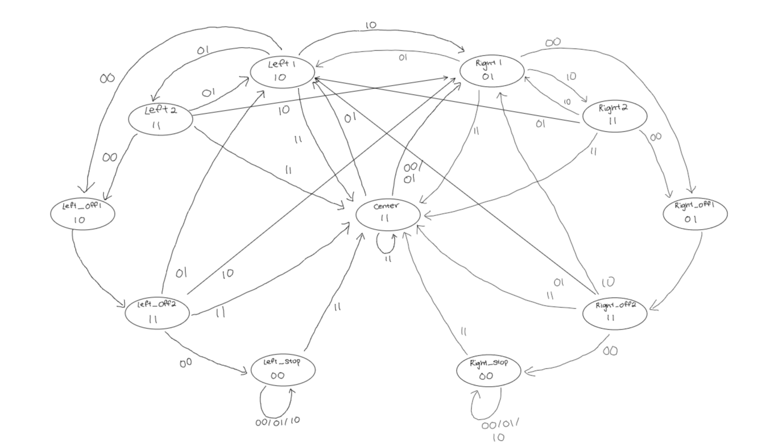

1. Section 7.3. Write down the procedure to initialise P2.4 to be an input pin with internal pull-up resistor

**P2 -> SEL0 &= ~0x10;**

**P2 -> SEL1 &= ~0x10;**

**P2 -> DIR &= ~0x10;**

**P2 -> REN |= 0x10;**

**P2 -> OUT |= 0x10;**

1. Section 7.3. Other than the List within List method used in the original Lab2_FSMMain.c, which other construct is commonly used to implement a FSM?

**typedef struct**

1. Section 7.3. What is the purpose of toggling LED within the main routine or ISR?

**To give the user an indication on whether the FSM is working as intended.**

1. Section 7.4. Which of the three functions Reflectance_Read(), Reflectance_Center() and Reflectance_Position() will give the best accuracy for the location of the robot with respect to the line?

**Reflectance_Center() will give the best accuracy.**